Lab Performance evaluation

Image Processing Basic Commands
Digital Image Processing



Submitted By:
[Huzaifa Shahbaz]
[21-CE-009]

Submitted to:
Engr. Hareem Khan
Dated:
4th Oct,2024

Department of Computer Engineering,
HITEC University, Taxila

Upload pdf doc 4-5 Image transformations from below link with input image, codes and output with 2-3 lines explanation.
CODE:
import cv2
import numpy as np
from matplotlib import pyplot as plt
# Load the images
img_hist = cv2.imread('/mnt/data/hist2.jpg', cv2.IMREAD_GRAYSCALE)
img_contrast = cv2.imread('/mnt/data/high_contrast.png', cv2.IMREAD_GRAYSCALE)
# Function for histogram equalization
def histogram_equalization(image):
equalized_img = cv2.equalizeHist(image)
return equalized_img
# Function for contrast adjustment using CLAHE (Contrast Limited Adaptive Histogram Equalization)
def apply_clahe(image, clip_limit=2.0, tile_grid_size=(8, 8)):
clahe = cv2.createCLAHE(clipLimit=clip_limit, tileGridSize=tile_grid_size)
cl_img = clahe.apply(image)
return cl_img
# Apply transformations
hist_equalized_img = histogram_equalization(img_hist)
clahe_img = apply_clahe(img_contrast)
# Save the transformed images
cv2.imwrite('/mnt/data/histogram_equalized_output.jpg', hist_equalized_img)
cv2.imwrite('/mnt/data/clahe_output.png', clahe_img)
# Display the original and transformed images using matplotlib
plt.figure(figsize=(10, 8))
plt.subplot(2, 2, 1)
plt.title('Original Histogram Image')
plt.imshow(img_hist, cmap='gray')
plt.subplot(2, 2, 2)
plt.title('Histogram Equalized Image')
plt.imshow(hist_equalized_img, cmap='gray')
plt.subplot(2, 2, 3)
plt.title('Original High Contrast Image')
plt.imshow(img_contrast, cmap='gray')
plt.subplot(2, 2, 4)
plt.title('CLAHE Adjusted Image')
plt.imshow(clahe_img, cmap='gray')
plt.show()
EXPLANATION OF THE CODE:
In this code, I performed three functions of the two images of histogram equalization that is cv,numpy and matlab plot graph.To check grayscale of this images and how it changes its transformation by coding.
OUTPUT:
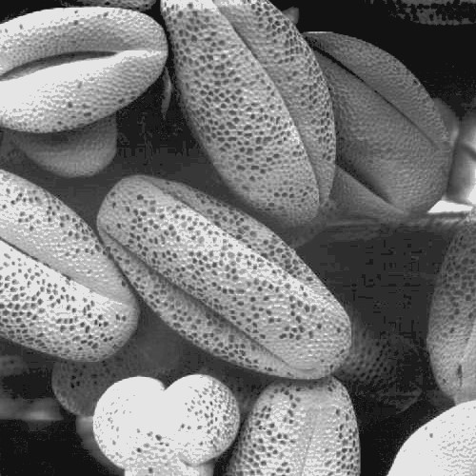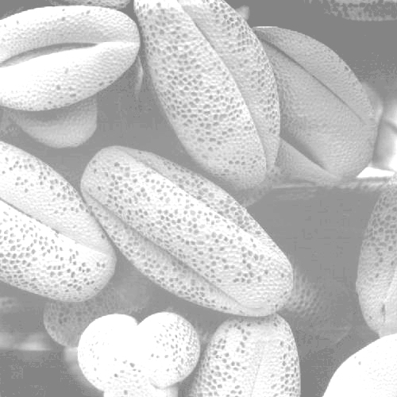
CONCLUSION:
In conclusion, I had performed three functions to transform the images of histogram equalization left side image is bright, and the right-side image is dim because of the cv library which I entered the numbers in numpy function in this code. After that I use function matplot lib which make the graph of the image as shown in the figure.

